Singing Magician

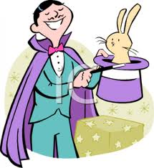
The magician was singing in the kitchen. The magician grabbed out his hat pulled out a rabbit. He did magic. The magician was singing This Is a Part of me by Katy Perry. He would not stop singing it but he did finally stop and the neighbors thanked him when he stopped. When the neighbors left he started singing again. The neighbors slammed the door wide open and said stop singing. The magician said no. they said but why are you singing because I want to. But we asked you to stop so you should stop! And I said no because I love to sing people! So just go home now go on shoo-shoo. No way we asked you to stop now stop this instant! The magician screamed like a girl scream and left very sadly.

Meanwhile the magician was still singing. The magician was singing all night. When he wake up he was still singing the neighbors couldn’t even go to sleep.
Finally the magician got tired and wants to sleep. Right when the magician stopped singing the neighbors were so happy. Then the neighbor’s want to sleep. When the magician wake up he thought that he doesn’t like singing .so he said he likes dancing.

