A Failed journey
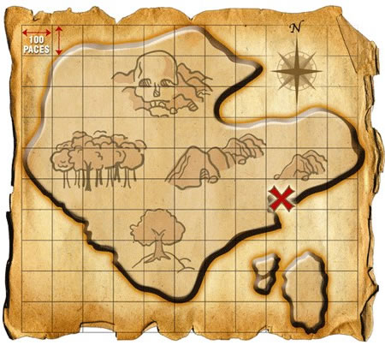
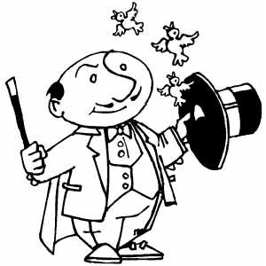
The magician was searching for a treasure map in a terrible storm. “I am going to find that map with my powers!” The magician tried everything but with blizzard the powers will not work which means I am no closer to the map. The magician started to cry and he throws down his wand then all of a sudden the wand started to glow and it flew back into his hand. “Who is pranking me” shouted the magician. “`Show yourself.”
Bushel bushel, bushel, bushel. “What was that?” whoosh whoosh. “C’mon you guys this isn’t funny. Whoosh. Alright this better work. Rahhh Hoboken. Well if it isn’t Houdini and criss angel. Suddenly they disappeared. “Poo” complained the magician. He went on his hunt again for the treasure map. He used his powers to fly above in the forest to look for the x. he couldn’t find it because the forest was so thick. He flew back down to the ground. He started off again this time walking and searching every square inch of ground in his sight. Nothing. He found nothing. Suddenly he came across a place that he thought had an x. but it didn’t. He started continuing his search.
“Magician” a delicate voice said. “What? Who are you” said the magician. Show yourself no one answer. They did not answer. The magician left. Then the magician did a spell. It backfired and he became even fatter than he already was. He tried another spell but then he vanished into the plain darkness. He admitted he was not magician just a silly old fat man. But the kid felt bad for him so they went into his castle. And they made him fatter by forcing him to eat food but then he became skinny again and then he regain his own powers he tried to ZAP the kids but the kids took wands and trapped him into a cage after he was trapped into their cage he locked the castle so no one could get in or get out! Then the kids took the map and teleported out of the castle. Just to tell u that if you are in the cage you can’t do any spells. So the fat wizard was trapped in the cage and stayed there FOREVER! I cannot believe this says the wizard to himself! He cried and cried all day long he did that forever! One Day I will get out of here!!

