The Robbery
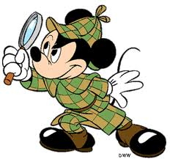
The detective was crying in the terrible storm. It made him stun the sun outside. The detective is searching for clues until he stop crying .First, he find a thunder storm cloud then, he found a blue hair, last , he found a thunder superhero suit. So he put it on and he was able to shoot lighting out of his hands he said he was “white lightning” he went to the bank and was depositing a check and then a robber came in and had a knife he said “everybody hand over their money or else” “or else what ““be-boom” I don’t think so” “I do” “I don’t” “I do’’. Finally the detective brought out his phone and said “run away or else I will call 911. They ran away. Then, the detective saw ghosts. They were thieves’ ghosts. He was a super hero he didn’t need to call 911 the robber said “well mister hero what will it be. “ “Neither” he shot the burglar with lightning and knocked on the door of the police station and left the burglar there the cops we confused. In the news the next day “mystery hero saves the day captures thief of ages.” He was very proud. And went to sleep longer than ever before. When he woke up from his deep sleep he said” oh no there must have been a lot of robberies since I have not been helping out. He got start to work. He put on his suit and then went outside. He started by saving a girl from a fire. Then he staid by a bank for the night just in case. He indeed up catching a robber. Then he went home to get a snack, but when he went inside there was a robber in his house. So he went and coughs him and took him to jail. He said “your staring here buddy forever in jail ‘’.
He heard ghosts to steal the food. The detective was chasing them around and around. Then finally he was tired, He can’t see ghosts. The detective was shining the light over the ghosts. The ghosts were scared, they went away. The detective said “boo’’! The ghosts never come back. He discovers cat prints swimming in lava. The cat’s colors were gray and black. The cat walked in into the

