The superhero and his awesome painting

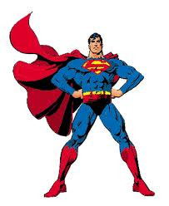
The superhero was painting in the terrible storm he was drawing a pitcher of flowers. He was getting all wet. He was socked but he kept on drawing. It started pouring down rain. When he was done drawing the flowers he started to draw a horse. All of a sudden it started to snow and it was getting worse by the second, but he kept on drawing, and he was not stopping. The super hero painter would’n stop he would keep on going and going even if it was a freezing
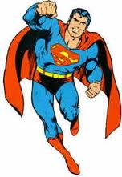
He finally got to cold so he went in his garage and some body knocked on the door it was his arch enemy doge ganger. He took the super hero and the super hero burned him because he had a heat soot. After a good snack, he went back to painting he had been working on it for years and he still was not done. And said something is missing on my painting many years he has still had been working on it then he heard somebody open the door it was the robber he tried to run away but the superhero tied the robber up and said not so fast .
I have been tracking you down and I saw you robbing banks and stealing stuff I will put you in jail now I will go to sleep good night.

