The Painter
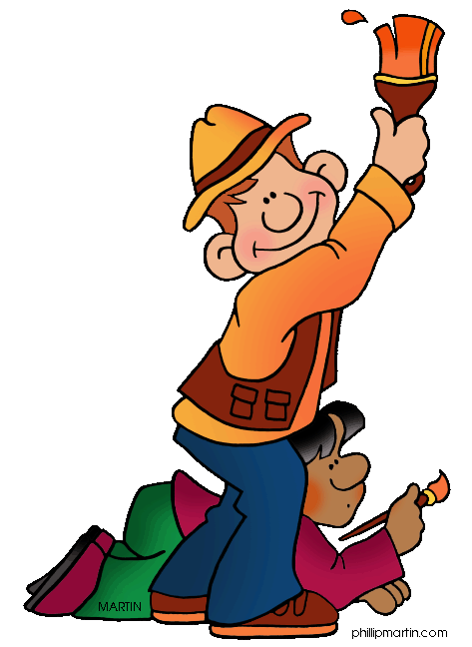
The explorer was drawing a picture in the kitchen. There was a painter in his kitchen thinking what he can paint. He was looking for something to paint in his kitchen. He painted a house it was not good. So he painted a cat it wasn’t good .He tried to paint everything but he couldn’t paint everything. So he went off. And he went to the basement and leaned on the wall and opened a secret sanctum and found a bow and arrows he made a suit he called himself night hunter he went out and stopped every robbery. Extra extra mystery hero saves the people say he where a hoodie and jeans and had a bow he was called night hunter. He slept all day. He was thinking in his sleep what he can paint. He was thinking a lot of things to paint. He saw a cat, a dog, and a zebra from the zoo. He saw lights, plants, sofas, and horses from the farm.
He came back home and paint everything what he saw. The next day he went and to the bank he always had his compact bow with him he was depositing a check he got. A robber came in and he pulled out his pulled his hood on and said “Don’t move.” He dropped the gun it was a squirt gun he laughed “squirt gun! Lame.” “Meh, meh, meh.” Once again he caught the robber.

