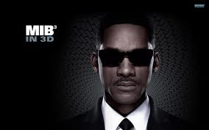
MIB (Men In Black)
XD XD XD XD XD
Agent J blasted The Jeff worm! There are squid babies and Jeff worms. Those things are aliens. Some of them are funny. The main characters are Agent K. and Agent J. Men in Black stands for MIB. MIB is my favorite movie. They have guns and stuff like that. The movie is great! I saw MIB and MIB 2. The squid baby could suck anything into his mouth. He sucked up Agent K but he got out all slimy.
Jeff worms are huge aliens that try to rip your head off. In the movie my little sister got scared. My favorite character was Agent J. The Agents had huge and large guns. I would have THAT gun .
Agent J is better at shooting aliens. MIB is one of the best movies ever! There is a lot of violence. Iron Man could shoot power balls. But I think MIB is better. There is also an alien that has snakes coming out from his nose. I forgot what his name was. The movie was rated PG-13. Squid babies are the weirdest thing in the movie. My favorite part was when the Jeff Worm threw Agent J on to the street. He wasn’t hurt! My favorite MIB was MIB 2.

The End
