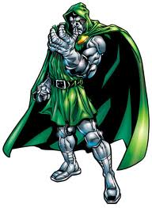
Wonder Woman Super Villain
The grandma was walking in the garage. She was going to find her trophies. When she was a little girl she played soccer she also was wonder woman. Then a super villain came and stole her trophies. Then she kicked his face .BAM. Since the super villain also had super powers, he recovered quickly from the kick.
He turned to the wonder woman grandma and said, “You will not foil my plains to take all of your trophies and extract all the pride and excitement out of them that was deposited inside the trophies the day you touched them. I will then take the emotions and create a super villain robot that will fight these wondrous feelings of success to make this world into a bunch of losers. I will then win every soccer game!”
Then Sends that happened she started winning all the soccer games .she played with her team at the park on all the weekends she had to have a little practact

