THE HAUNTED HOUSES

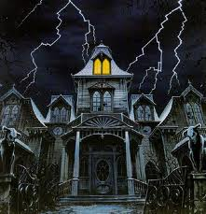
The boy was carrying an envelope in the haunted house. Then something happened the boy heard a loud scream and he ran as fast as he could to the door but it was locked. The boy got really scared but he ran up the stairs to his room and he hid underneath his bed. But the monster grabbed his leg and pulled him out from under his bed. Then the monster threw him against the wall. But he got up and ran down the stair but tripped while on his way down. And then he looked up and there was a ghost on the side of him. Then the ghost went right out the house then I went out the house and went to a deferent house.
When he went in the new house and a ghost attacked him. He was so scared. But he ran into the grim reaper it cut his face. He was badly injured he fell into the sewer. Then he grabbed a latter he was somewhere in the basement. He was lost in a haunted basement. How could this get in any worse? The boy was so scared and lost. There was ten zombies in the basement with him. It was just so freaky then he punched one of the zombies.

