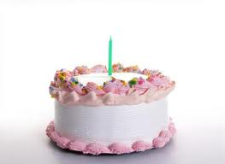
Grandma’s most best birthday

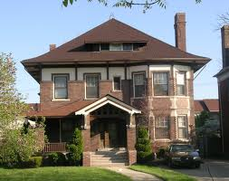
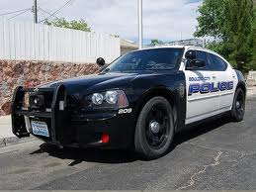
The grandma was walking in the backyard. The grandma is gonna fall over sooner or later. I think she is going to die. She is soooooo old. Why is she so old!!!!!!!!!!!!!!!???????????? Her birthday is tomorrow. She is a wacky syco person. She is 1,000 years old and walks with a cane. She likes pie. She bakes cookies with her imaginary cat. She is very strange. She sleeps in an empty pool. She thinks she is a wizard. Freaky, huh? She thinks that she is the ruler in this world. But she has a medical problem. Her problem was really serious. She had back pain that really hurt .It was really impossible to heal at all. Today was her birthday and she made chocolate fudge cake for herself. She was so lonely without any company. She was poor a little because she didn’t have as much money. She blows the candles off the chocolate fudge cake. One of her grandson’s smashed her face in the cake “SURPRISE” the grandson said. After she took the chocolate fudge off her cake she started laughing. The grandma took some of the chocolate fudge cake with her hands and splattered it on her grandson’s face. Both of them started laughing, “HAHAHAHA”. They both went inside to go wash off the fudge cake. Once they went outside they looked at the table where the cake was and the cake wasn’t there. The cake disappeared and no one was there but the grandma and the grandson. So the grandma and the grandson looked around the house and there was nobody at the house. Then the grandma started thinking that maybe her imaginary cat ate the cake. She was really worried because she didn’t have any money and she couldn’t buy another one in time. She was scared because her grandson was really hungry. She wanted to make a good impression on her own grandson. This would be a disgrace if she didn’t. She started to think. Suddenly, the little light bulb above her head, lit up. She had an idea! She went outside and she asked everybody that she can help with groceries when she got a lot of money she went and go buy a cake. But there was a problem right at that moment she forgot where she was .She started to lose her memory little by little then she fainted the police came and took her to the doctor’s room. The good thing is that she did not die but she had a medical problem of bad memory but she woke up at the hospital and her grandson was there with a cake. “SURPRISE!!! I GOT A CAKE!!!”Said the grandson. “Well it is my 1,001 birthday but it was the best birthday I ever had.” said grandma as she hugged her grandson.
The End!

