If I Were In Charge of the World
If I were in charge of the world,
I’d cancel rules annoying people, and signs of aging beyond 21. ------------------------------------If I were in charge of the world, there would be 4-dimensional video games, talking dogs,
And much larger chocolate bars.
-------------------------------------If I were in charge of the world,
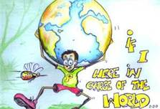
A person who doesn’t like vegetables,
Isn’t very fast, and is afraid of spiders,
Would still be allowed to be
In charge of the world.

