The Superhero and the Robber
The super hero was painting in the terrible storm as he heard somebody knocking on the door it was a robber he pushed the super hero out of his way and as the superhero fainted to the floor the superhero woke as soon as he could the superhero found that he was tied to a rope
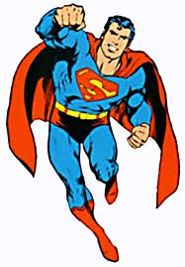
He used his super powers to get out. When he got out he looked around and his million dollar panting was gone he got his suit on and then he flew out the storm was at its worst. So the super hero was flying because he was trying to look for the robber. He saw the robber get in his car. The robber stopped at the bank and cashed in painting as soon as the superhero arrived at the bank he said stop right there. The robber ran into the woods so the super hero hade a plan he had seen e robber before there was a let out at the end of the woods the robes hide out was there. He snuck around in a bush by the door. The robber out of berth unlocked the door and the super hero got the robber but the robber instead got the super hero and locked him in a dark closet. The super hero had a little flash light and a key to open doors. So the super hero opens the door. The robber got away the super hero was so sad.

