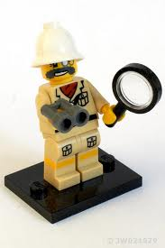
Mom Day
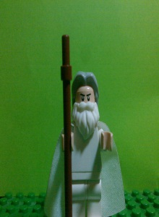
The explorer was skipping in the elevator .the explorer got out then he saw his enemy. Then he pulled out his gun and started shooting at his enemy. Next, the enemy, whose name was Shock-gem Peter, got out a magic crystal which froze the explorer’s bullets. Next the explorer dropped his gun and started slapping Peter. Then Peter started crying, “Mommy!”
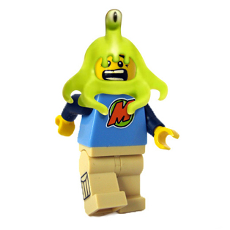
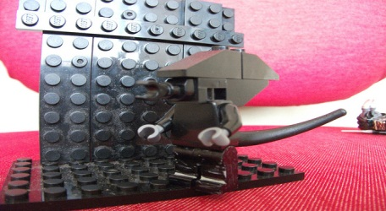
The explorer now went on another adventure. But Peter missed his mommy. The explorer went home and got his Mommy bear from build a bear workshop he was dressing it when all of a sudden a boy named Gallop rode in on a horse with his mom tied up! He went to planet 77 on his horse.
Then he went to moon but got invaded by AILEN.T

