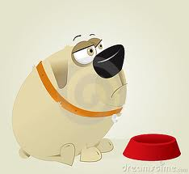
The Witch
The witch was looking for clues in the secret room. The witch was looking for clues because she needed to get ingredients for her brew. The secret room was full of ingredients. The witch noticed that a thief had stolen some of her things.
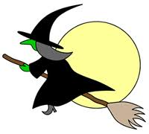
“Argggggg” complained the witch. She was mad that someone had taken her things. She started searching for clues. The witch was a nasty old lady with scraggly hair, warty nose and terrible dirty skin and fingernails. She was hideous. She started searching for clues in the secret room. While still gathering what was left of the ingredients she found her first clue. A dusty fingerprint. She growled.
“Wicked people taking my things!” she cackled
“I’ll get those snottywags if it’s the last thing I do!!!!!!!!!” cracked the witch. She was extremely angry. Then she fell in a pile of poop. She got so mad she exploted and then I had a shovel in her hand and wacked her guts but she came back to life as a magical grandma and hauntyed her. Finaly she got away from the curse because the evil witch was her mom.she was not happy whene she found out .then she got a dog named Popo and cald it po for a nickname. Popo is a dokson labador just like my dog, Coco Shenelle Sansoni. Anyway, Popo was curious I’m so sorry coco is my friend middies dog I forgot. Anywhay where was I, Popo was a curious dog and had and was hipper AKA jumping off walls hiper.so Popo was cool.
The dog tried to eat her. She was chased by a dog that is hyper. She was eating and started getting fatter and fatter she was soooooooooooooooo fat she almost exploded!!!!!!!!!!!!!!!!!!!!!!!!!!!!!!!!!!!!!!!!!!!! She was trying to do jumping jacks but she could not even starch out her arms. Popo found her again and ate her up. She was trying to lose weight but she gained weight! She pooped in the middle of her run she yelled I’m getting FAT! She became weird and boogers dripped out of her nose she was HIDDIOUS! Her boyfriend left her she had no more powers now her name is Fat women she makes people fat my hypnotizing them she gets fat all the time her child became a Chinese PANDA! That’s because she is Chinese! “HONG KONG LONG NONG” said her it means I like being fat I want to explode and get fatter please make me fatter she begged. Everyone wants her fat everyone rolled her. “You done yet?” people say to her in the pooping room .she says she is the opposite of being constipated. Suddenly the witch came back and casted a magical spell on the dog. The dog became very skinny and tiny and soon she was no more. The evil witch’s mom had put a bomb in the earth and in 8 wait no 7 no 6 no 5 no 4 no 3 no 2 no 1 wait now it blew up. So now the witch and dog are no more. There was nothing left. Or so you think. The witch acted a little too weird when she was around humans. She wishes that she was not as ugly. People did not even dare to look at her at all. The witch tried to find the spell that she needs in order to be pretty. She finally found the spell. She used on herself and it worked.

