People That Lose pet.
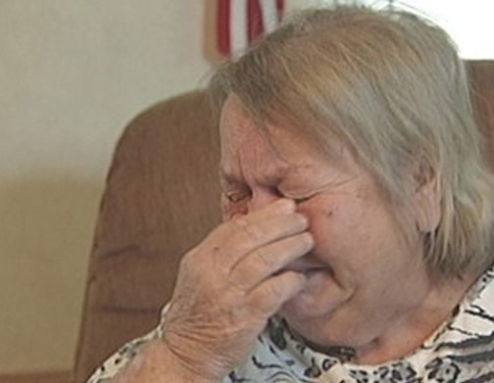
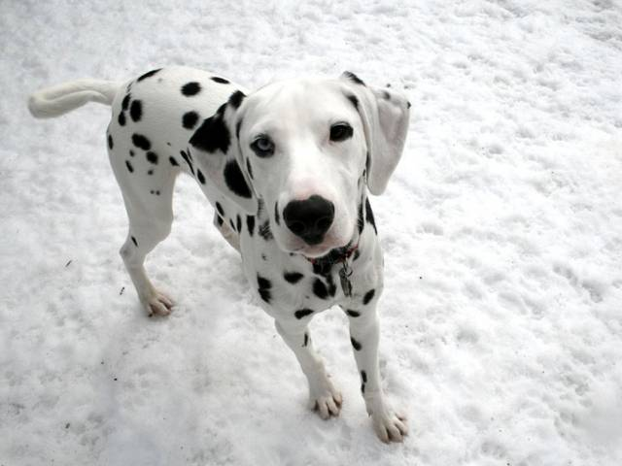
The grandma was crying in the park. She was crying because her poodle ran away and now she can’t find her poodle anywhere. So the old lady went to looking for her runaway poodle. She went to the park to find him. Then she got an idea. She asked people if they have seen the poodle somewhere. One of them said that they saw one going to the plaza. She ran fast as she can . She got to the plaza on time and found some poodles. She was too excited and could not pick her own poodle. After a few minutes, she called-out her poodle’s name, Charlie, and a dog came up to her. It was her runaway dog! She was so happy that she cried.
She and her poodle went home to rest. Then they found a bantered dog.
SO the grandma and Charlie went on a search to find the perfect owner for the abandoned dog. They took the dog shopping, to see if anyone would take interest. They bought the dog some clothes, so he could be warm. They even went to a dog spa so his fur would be nice and shiny for his new owner.
They all arrived home, no luck at finding an owner for the abandoned dog.
The next day, they went to the park. They all started doing tricks. The grandma did a cartwheel while Charlie and the other dog did flips.
Then, a man with no dog of his own spot the abandoned dog doing a backflip. He asked the grandma if he could have her and the grandma agreed. He named the dog, Teddy, because of how much she looked like a teddy bear. In celebration, they all went to get some ice cream. The dogs got treats because dogs don’t eat ic

