The Worst Day Ever
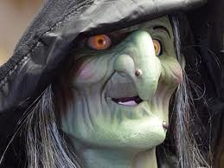
The witch was drawing a picture in the school. The picture was a big dog eating a toy. The toy was big too. The witch cast a spell on the drawing that made everything come alive. The students were terrified of the big dog. The dog was large and hairy with his tail pointing down.

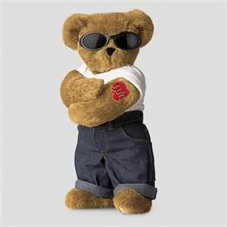
The toy was a teddy bear with a machine gun. He started shooting wildly around the room, so the room would fall down and crush every one. But the dog got mad and knew he was going to die so he bit the teddy bear’s arm. The teddy bear dropped the machine gun as the bears arm fell off. But he also had a knife in his stuffing so when the dog bit down on the bear the knife stabbed him in the mouth. The witch was watching the toy and the dog fighting and she said, “What have I done? Next thing I know I’m going to be a witch on a stick.” The students were just sitting in their chair watching. The teddy bear finally got out his knife from his stuffing and stabbed the little kids in the stomach. The dog jumped on his head to get some air then bit into a student.
The Teddy bears grandma went Rambo on every toy in the world until he was named king of the teddy bears. The grandma’s name was Jackzon . The dog peed out acid and burned down all the buildings and teddy bears. But the teddy bear was still alive and it smacked the dog in the face. The dog got a bench and started to hit him with it. Until the ted the teddy bear got a car and ran over the dog.
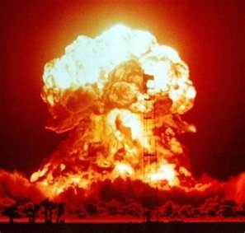
The grandma teddy bear was mad because she remembered that the dog king said if you ever kill one of my dogs I will send my dog army after you. And the grandma ran over the kings wife with a Ferrari but she was still standing so she cut her open and put a boom and her guts exploded with a big boom.

